**Seismology**

Seismology is the study of earthquakes and seismic waves that move through and around the Earth. A seismologist is a scientist who studies earthquakes and seismic waves.

**Seismic Waves**

Those waves which are radiated due to the Earthquake are called Seismic Waves. Seismic waves are incredibly helpful to figure out the location, estimate energy, timing. Seismograph is the device which is used in the Detection of the waves. Seismic Waves are of two types:

1. Internal Waves (Body Waves)
2. Surface Waves

**Internal Waves**

Those waves which propagates inside the surface of earth are called as Internal Waves or Body Waves. These waves have higher frequency & they carry more energy in compare to other waves. Internal waves are also of two Types:

* P-waves (Primary Waves)
* S-waves (Secondary Waves)

**P- Waves (Primary Waves)**

P waves or Primary waves are the first waves to hit the seismographs when an earthquake strikes. They are longitudinal waves which means that the direction of motion and propagation are the same.

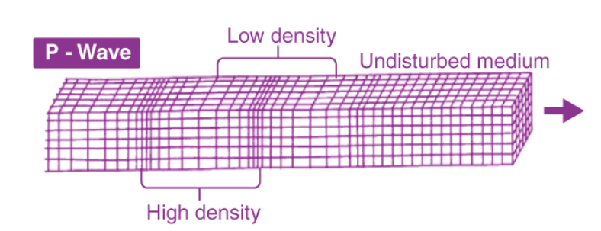

Figure . Figure of P- Waves

Sometimes, Some animals are able to detect the P-waves. We often Heard, Dog are capable to detect the earthquake which is true, but animals like dog bark & shows strange signals not only in the case of earthquake but can show strange signals in other scenario. So, its not very effective wave to detect the Earthquake

**S-Waves (Secondary Waves)**

Those waves which reach the surface of Earth after the primary Waves is called S waves. They are the second fastest waves. They have almost half the speed of P-Waves, they still travel fast. S waves are of the transverse type.

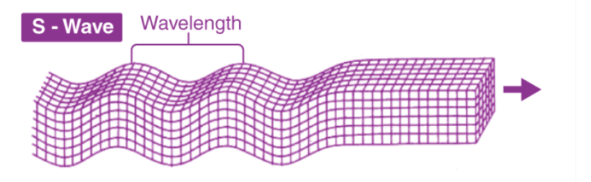

Figure . Figure of S- waves

**Difference Between S-waves & P-waves**

|  |  |  |
| --- | --- | --- |
| S-waves (Secondary Waves) | **Base** | P-waves (Primary Waves) |
| P waves are the first wave to hit the earth’s surface. | Timing | These arrive after P-waves |
| These waves travel in the speed  range of 1.5-13 km/s. | Speed | These waves are almost 1.7 times slower than P-waves |
| These waves travel in a linear direction | Direction | These waves travel in a transversal direction |
| It can travel through solid liquid & Gases | Medium | These waves travel through only solids |

**Surface Waves**

The seismic waves which travel only on the surface of the earth are known as surface waves. There average speed of travelling is 2 to 3 km/s. The surface waves circle the globe many times. The primary waves which are come from the core of the earth are converted into surface waves. Surface waves are responsible for the major destruction of life & property in the Earth. There are two types of Surface waves:

1. Rayleigh wave
2. Love waves

**Rayleigh waves**

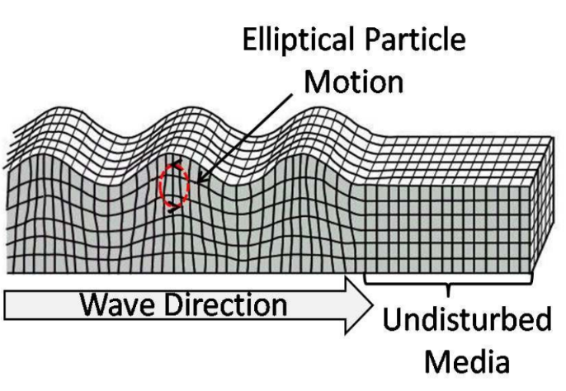The seismic wave which propagates on the earth surface (solid surface) in the combination of longitudinal & transverse waves is called Rayleigh wave. It is just like the wave in the ocean because This wave rolls along the ground just like water. It moves group up and down, and side to side in the propagation of the wave. Sometimes they are also referred as rolling waves.

Figure . Figure of Rayleigh Wave

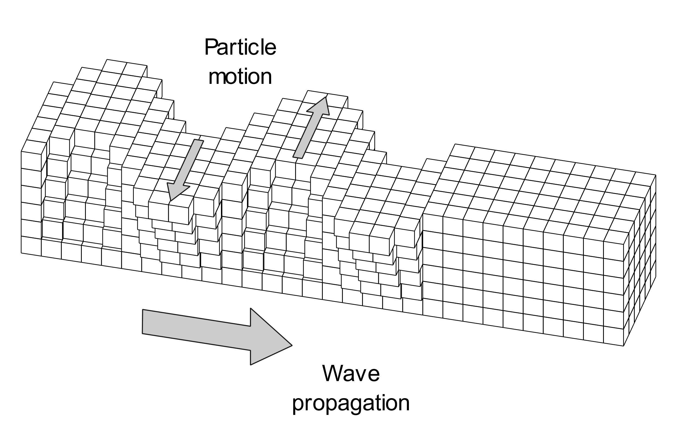**Love waves**

The seismic surface wave in which medium particles vibrate side to side perpendicular to the propagation of the wave is called Love wave. The work of the love wave is the opposite to its name. Love waves are very destructive in Nature. Love wave is a transverse wave in which medium particle only vibrate only side to side perpendicular to the propagation of wave.

**Wave pattern of Gorkha Earthquake 2015**

The unexpected & sudden movement of Surface of the Earth is known as Earthquake. A big Earthquake occurred in Nepal on April 25, 2015 (Baisakh 12, 2072) at 11:56 AM (local time) which is known as Nepal Earthquake or Gorkha Earthquake. About 9000 people were killed, many thousands more were injured, and more than 600,000 structures in Kathmandu and other nearby towns were either damaged or destroyed.

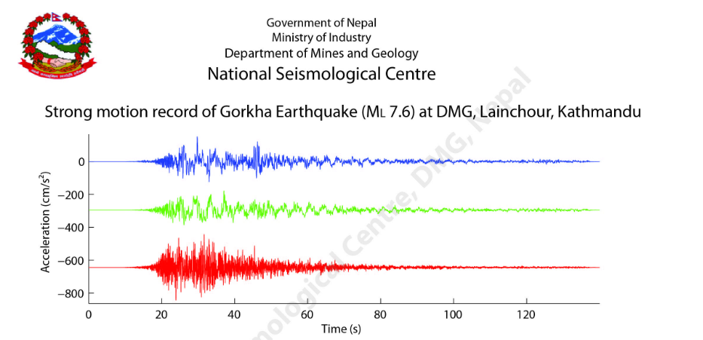

**Gravitational Waves**